- ​
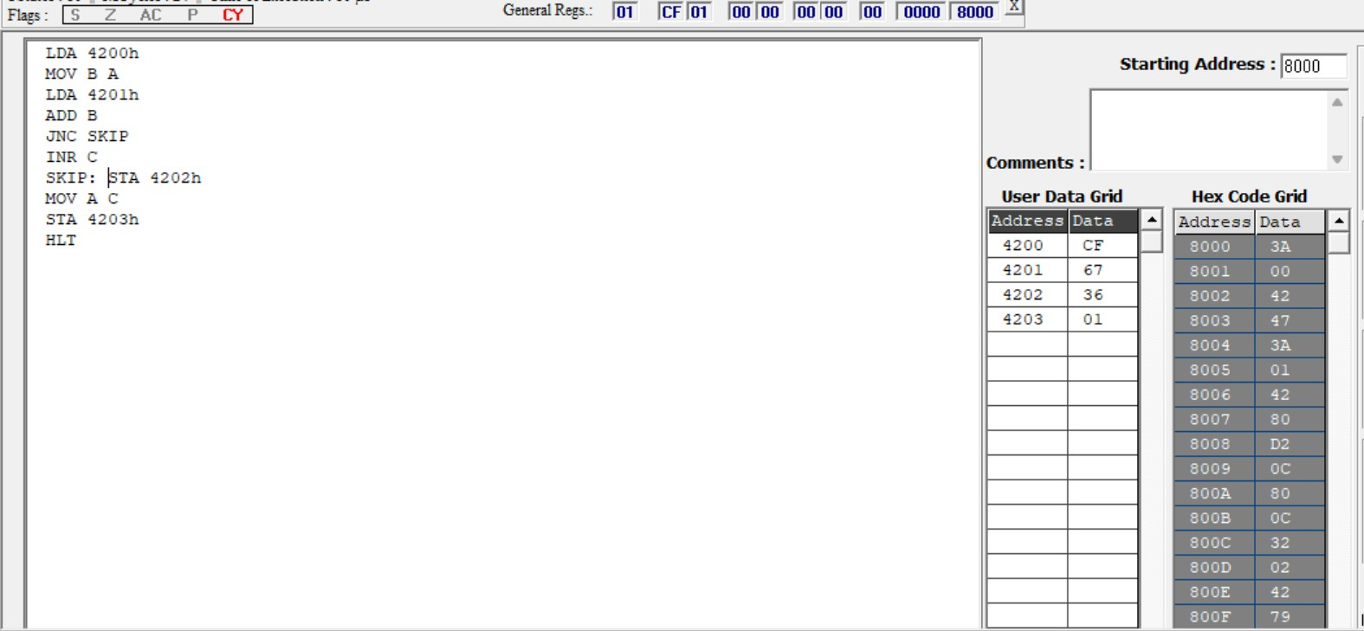
A.8-BIT ADDITION WITH CARRY USING DIRECT ADDRESSING

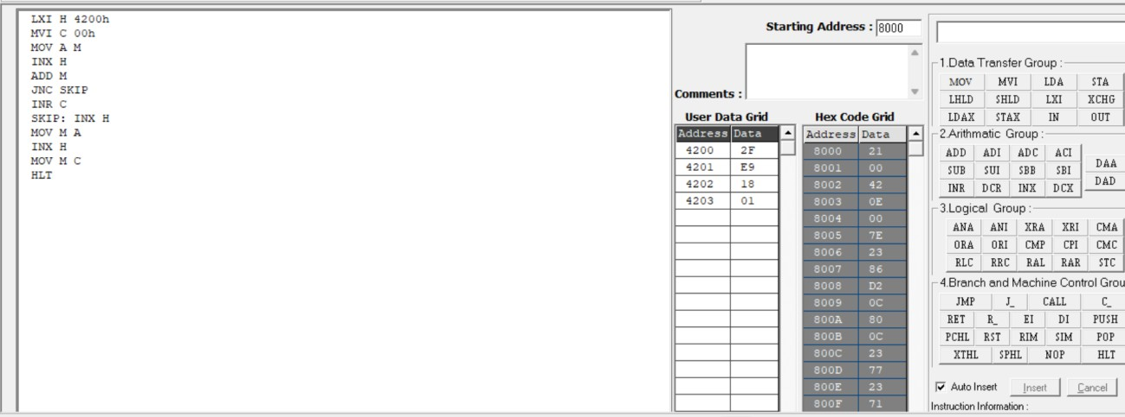
B. 8-BIT ADDITION USING INDIRECT ADDRESSING

- 8-BIT SUBTRACTION WITHOUT BORROW

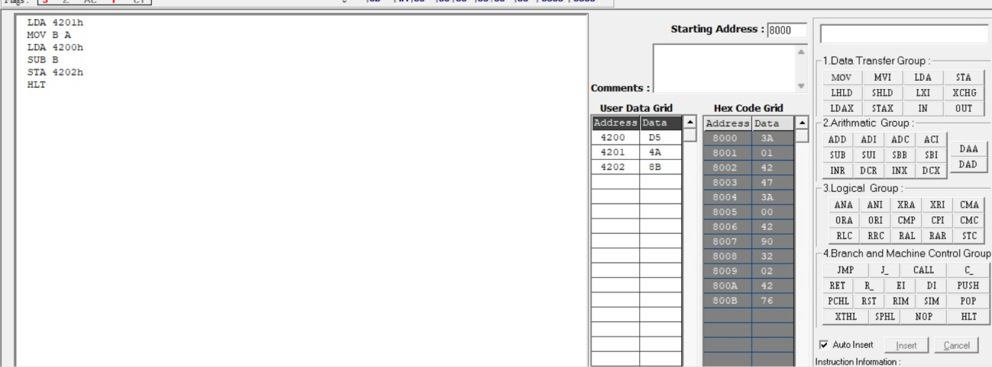

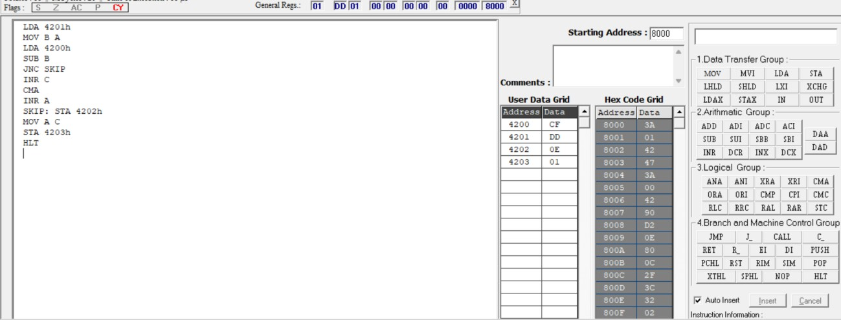
- 8-BIT SUBTRACTION WITH BORROW USING DIRECTADDRESSING

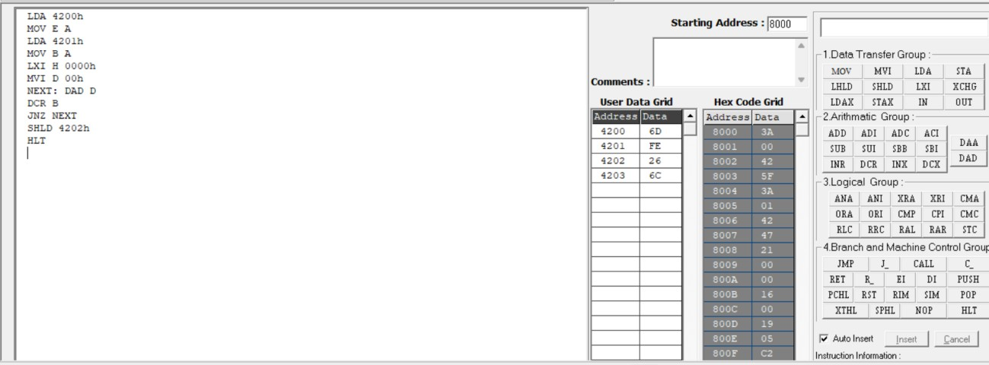
- 8-BIT MULTIPLICATION OPERATIONS USING 8085MICROPROCESSOR

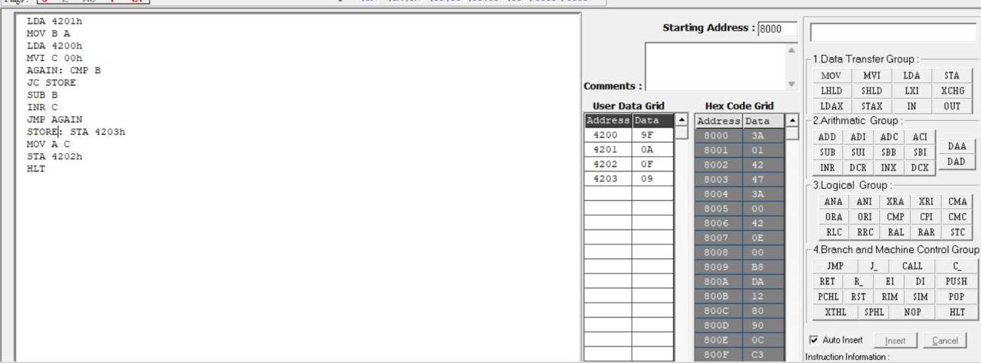
F. 8-BIT DIVISION OPERATIONS USING 8085MICROPROCESSOR

- ​
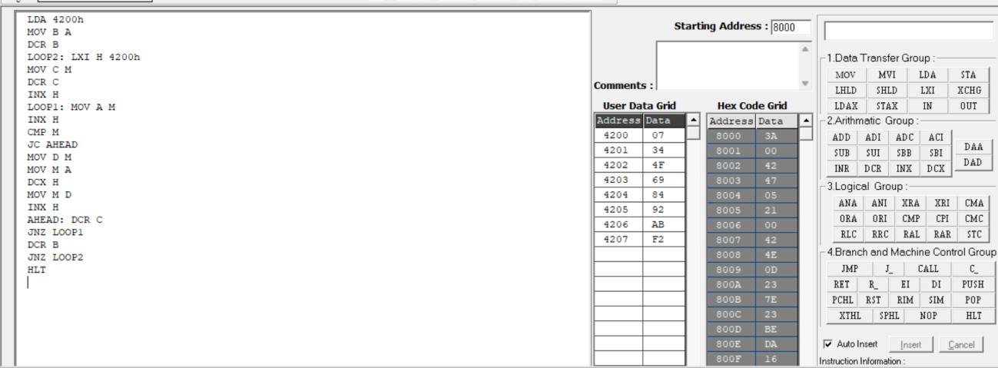
- SORT AN ARRAY OF DATA IN ASCENDING ORDER

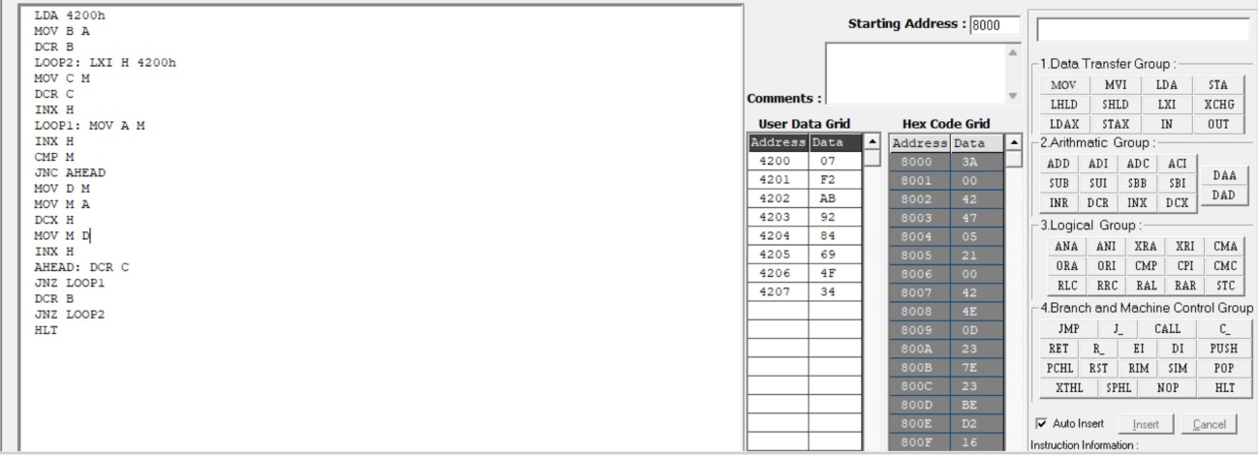
- SORT AN ARRAY OF DATA IN DESCENDING ORDER

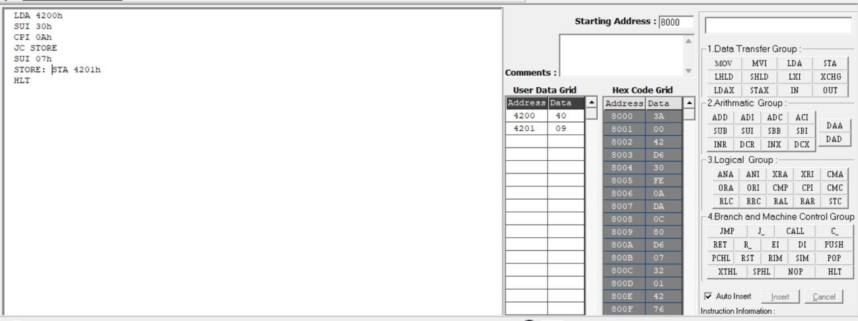
- ASCII CODE TO HEX CODE CONVERSION

- TRANSFERRING A BLOCK OF DATA BETWEEN MEMORY LOCATIONS
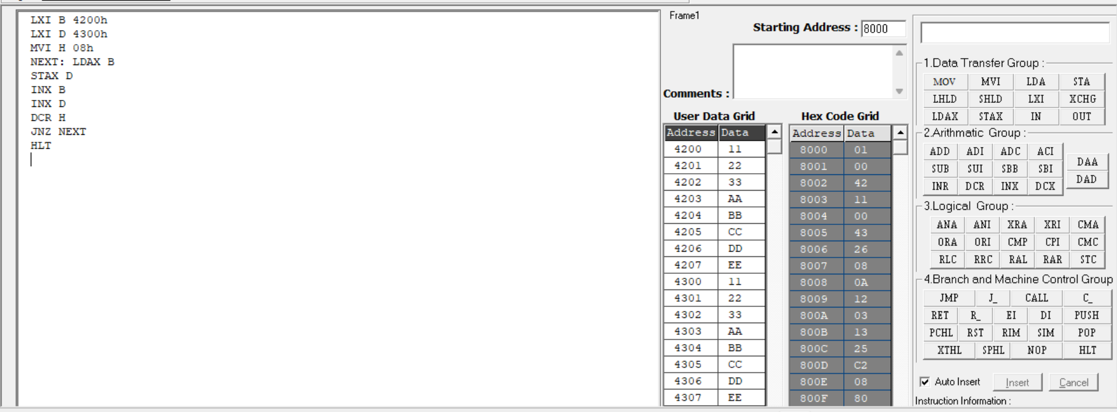
- ​
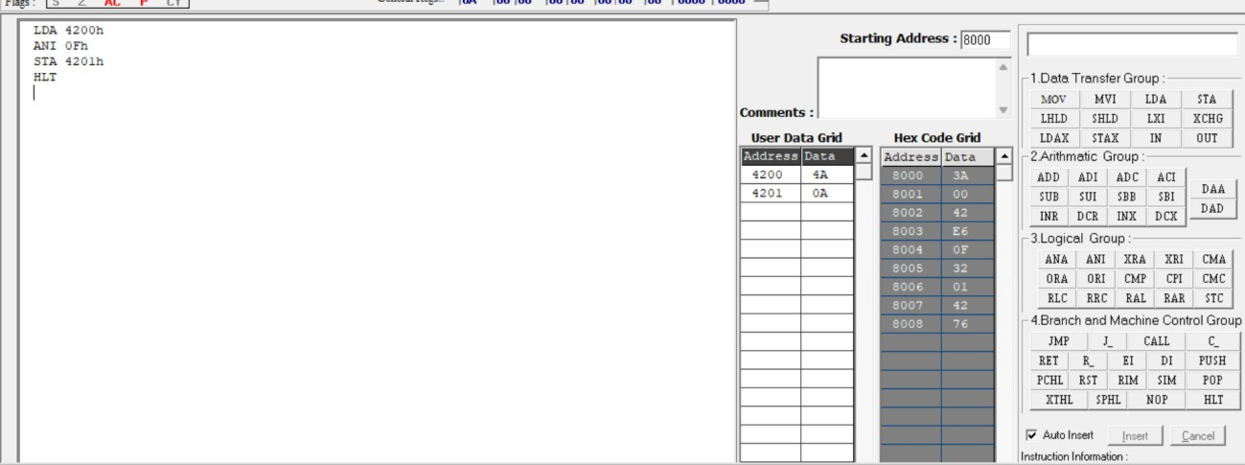

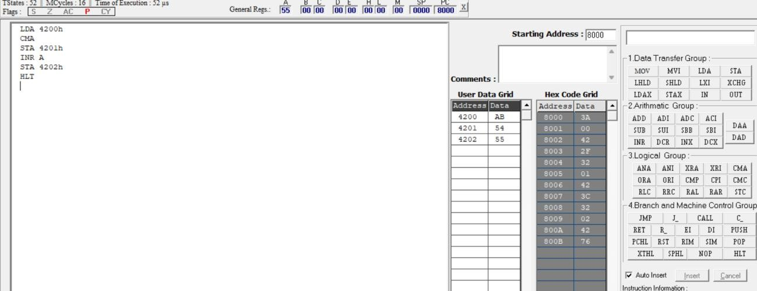
5b.ONE’S AND TWO’S COMPLEMENT

